Release Screen:

1. Project Name Text not properly displayed.(It displayed like “Pro’i’ect”).

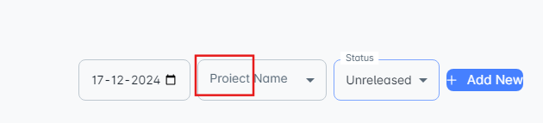

1. Need to change Add new button design.
2. Add Release-Need to remove scroll function and make it in a single slide.
3. After add a release and try to edit the release, entered data is not displayed.
4. After send release mail to client, in received mail, in release date, year is not properly displayed. And also time displayed in “PST” format but it need to show in “UTC or IST” format.
5. In Client Mail Send tab,Without enter mail id and click send button, page gets accepted and moves to next tab. But it need to show valid alert message for TO mail address.
6. In Deployment Request tab, CC tab is not able to modify.
7. In Deployment Request tab, After enter valid To email address and click send button, mail is not received.
8. In Deployment Request tab,Without enter mail id and click send button, page gets accepted and moves to next tab. But it need to show valid alert message for TO mail address.
9. In Deployment status, To mail address cannot able to enter.
10. In Deployment status, Without enter mail id and click send button, page gets accepted and moves to next tab. But it need to show valid alert message for TO mail address.
11. In Verification status, To mail address cannot able to modify.
12. After Verification status is completed, sign off text is displayed but need to add a separate button near to BACK button and not to store in the three dots button.
13. Release sign off pop up, need to add close button.

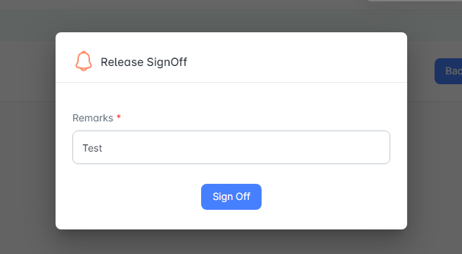

1. After create a release, created release time details displayed in UTC time.